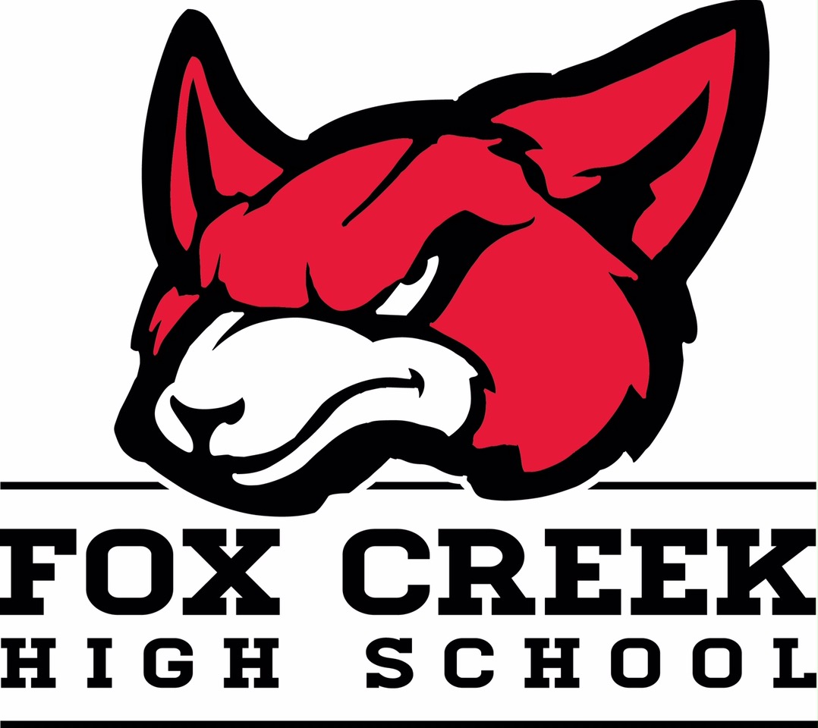

“Our Students Determine Our Future”

**BOARD OF DIRECTORS**

Greg Hurt

Mike Ray

Deadra Oliver

Roby Gillespie

Brad Whitfield

Tom Cotton

Greg Shaffer

**BOD STANDARDS**

The School Board:

* Serves as an advocate for children and public education
* Acts with fiscal responsibility
* Understands and responds to community needs
* Conducts professional meetings
* Supports the Principal and Staff
* Acts ethically
* Demonstrates courage
* Works as a team
* Communicates effectively
* Makes sound decisions
* Stays informed
* Devotes sufficient time to duties

1. Call to Order (Time: ____________________________)
2. Pledge of Allegiance to the American Flag
3. Media Notification
4. Recognition of Guests
5. Approval of Agenda
6. Board Officer Elections
7. Approval of Minutes
8. Principal’s Report on Student Achievement
   1. Jostens Renaissance Presentation
9. Treasurer’s Report
   1. 2016-2017 Budget – Final
10. New Business
    1. Board Meeting Schedule 2017-2018
    2. Cameras at the Ball Fields
    3. Band Tower
11. Old Business
    1. Coaching Supplements
    2. Student Enrollment 2017-2018
    3. Restroom/Concession Stand and Scoring Tower
12. Executive Session (Action to Follow)
    1. Contractual Matter

Adjourn Time _________